Site: __________________________

Section one Applicant details
Please complete all fields.
Applicant / legal entity
Company [List company] Sole Trader [List individual]
Partnership [List all company & individual partners] Trust [List trustee/s and trust name]
Company name |  |  | ACN
1.
2.
Address
Email
Trust name & ABN [if applicable]

First director (proposed operator of the business)
Full name
Date of birth |  | Drivers licence no. & state
Home address
Mobile |  | Email

Second director
Full name
Date of birth |  | Drivers licence no. & state
Home address
Mobile |  | Email

Third director
Full name
Date of birth |  | Drivers licence no. & state
Home address
Mobile |  | Email

Documents to be provided:
- Copy drivers licences (or passports) of directors.
- Copy trust deed.

Section two Confidentiality agreement & privacy and purpose declaration

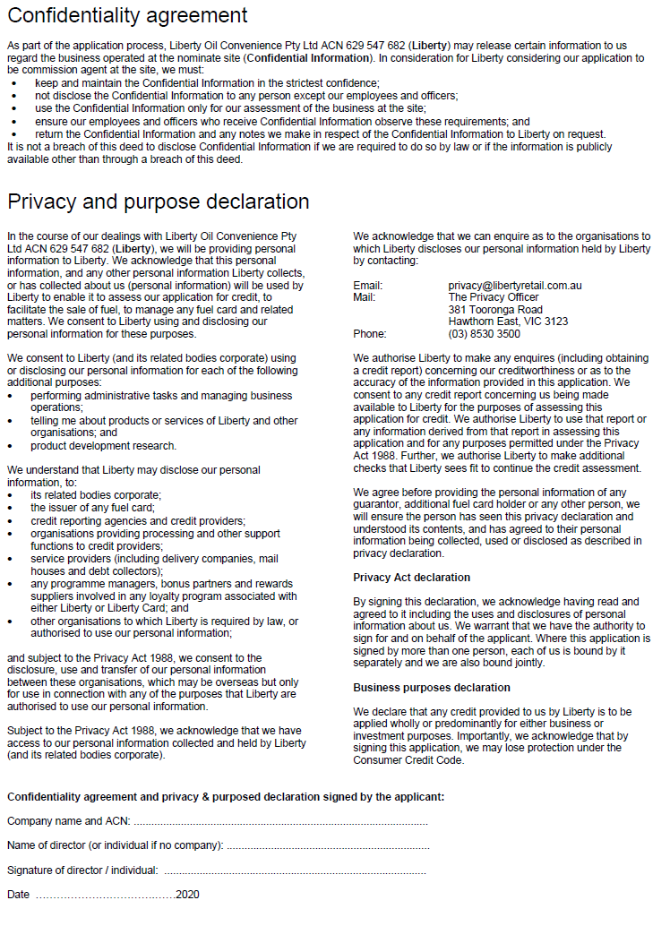

Section three Capital required to operate

*IMPORTANT NOTICE
You should complete this document based on your business plan for the site. To the extent Liberty provides any comment or information in relation to this application or the site, it does not make any representations as to future performance, turnover or profitability. liberty strongly recommends that you obtain independent accounting and financial advice to complete this application and before entering a commission agency agreement with Liberty.

Section four Financing the business

How do you propose to finance the total working capital of the retail outlet you are applying for? Please complete the below table and provide necessary documents. If assets are to be disposed of or utilised in the business, please specify. Note, Liberty may request forecasted profit & loss and cash flow statements during the approval process.

Capital required to operate (from above) $_________________

Funded by:

Cash | $ | Please provide 3 months’ bank statements
Overdraft | $ | Please provide overdraft approval letter
Other loan | $ | Please provide loan approval letter

Section five Financial position of applicant and directors

For the applicant, please provide:
- Current balance sheet.
- Profit and loss statement and income tax returns for the past 3 years (or to the extent available).

For each director, please complete a statement of financial position in the attached form. For directors with joint assets and liabilities (e.g. husband and wife), one joint statement may be completed.

Section six Retail experience

Please describe below the retail training and experience of the applicant and/or the directors including details of businesses operated over the past 3 years including sales figures. (Alternatively provide a detailed CV)

Have you completed ACAPMA Training requirement? If YES, please supply evidence. Must be complete prior to opening/operating store.

Have you completed a Food Handling Certificate? If YES, please supply evidence. Recommended completion prior to opening/operating store.

Please provide three trade references:

Company | Contact | Phone
1.
2.
3.

Section seven Insurance

Please provide public liability insurance certificate of currency for at least $20 million noting the interests of Liberty Oil Convenience Pty Ltd and its related bodies corporate.

Please complete for each director.

ASSETS

Cash at hand and in bank
Name of bank or institution | Amount
 | $
 | $
 | $
 | $
Total (1) | $
Please provide last three months’ bank statements for each account.

Shares and other investments
Description | Market value
 | $
 | $
 | $
 | $
Total (2) | $

Accounts & loans receivable
Debtor | Type of debt | Maturity | Monthly payment | Balance
Total (3)

Real estate & mortgages
Address | Title details | Market value (4) | Mortgage amount (5) | Monthly payments | Net value
Total (4) & (5)

Other assets
Description | Market value
Description | Market value
 | $
 | $
 | $
 | $
 | $
Total (6) | $
Include interests in other entities, vehicles, personal property, etc. Please specify if any other person has an interest in the assets and provide details.

LIABILITIES

Accounts & loans payable
Lender | Type of debt | Maturity | Original loan | Monthly payment | Balance
Total (7)

Other debts & obligations
Creditor | Details | Amount
 |  | $
 |  | $
 |  | $
 |  | $
Total (8) |  | $
List all liabilities not listed above including insurance loans, alimony, child support, leases, contracts, legal, claims, judgements, bills of sale, taxes etc.

SUMMARY

Assets |  |  | Liabilities
Cash on hand & in bank | (1) | $ | Accounts & loans payable | (7) | $
Shares/investments | (2) | $ | Real estate mortgages | (5) | $
Accounts & loans receivable | (3) | $ | Other debts & obligations | (8) | $
Real estate | (4) | $
Other assets | (6) | $
Total assets |  | $ | Total liabilities |  | $
Net assets

